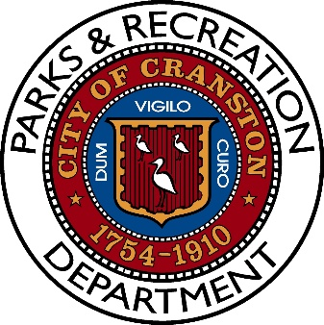

City of Cranston- Athletic Field Permit Request Procedure

The City of Cranston has artificial turf, soccer, baseball fields located throughout the city that are available to rent through the Parks & Recreation Department. A permit is required to use City athletic fields.

Athletic Field Rental Process

- Write a formal letter of request including:
  - Overview of your league and your membership
  - Dates requested.
  - Times requested.
  - Start and stop of the season.
  - Field locations desired (if known)
* Please note that a letter of request does not guarantee a permit.

- Provide proof of your group’s $1,000,000.00 liability insurance policy.
- Send request and proof of liability insurance to:

Parks & Recreation Department
City of Cranston
155 Gansett Avenue
Cranston, RI 02910
spiscopiello@cranstonri.org

- Once the letter is received, the Department will collaborate with you to identify available athletic fields for your organization, based on your request.

- Permit fees are collected before a permit is issued. Payment will be made by check or money order only. Cash is not accepted. Checks will be made out to the City of Cranston.

- A permit will be issued to your group for available athletic fields. A permit is required to use City of Cranston athletic fields when using multiple dates.

- Group will update their liability insurance policy as needed to include relevant City of Cranston athletic fields.

- Groups will be required to follow all Policies and Procedures to maintain their good standing permit.

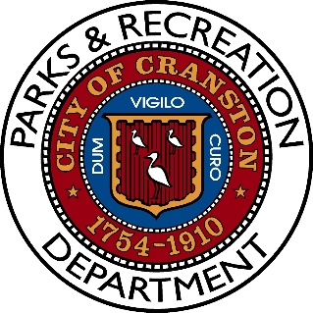

City of Cranston- Athletic Field Permit Policies

- All requests for Cranston athletic field usage must be made in writing within seven days of the scheduled event. Verbal request must be followed by a letter before permit is issued.

- Before a permit is issued, each organization must provide proof of liability insurance by submitting a copy of the actual insurance policy. $1,000,000.00 Liability Policy.

- Permit fees are due before the permit is issued. Payment will be made by check or money order only! Cash is not accepted! Checks will be made out to the City of Cranston.

- Permit fees can be found on attached sheet.

- Youth organizations within the city will be given priority for all field requests and will not be charged with any permit fees for the use of the fields.

- Returning organizations that remain in good standing with their permit will be given the opportunity to retain their permit at the designated complex. New permit request will be given field space based on availability.

- Organizations issued permits cannot sub-lease said permit to another organization. Any request to accommodate another organization must be cleared through the Recreation Department.

- The selling and consumption of alcohol at athletic fields is prohibited. Public urination, illegal parking and loud music is prohibited. Permit holder is responsible for the monitoring of these policies. Police will take action upon notification.

- Rubbish removal and general maintenance must be completed after competition. If said league produces a considerable amount of rubbish, the Department may mandate a dumpster, which must be installed by said permit holder at their expense.

- Failure to comply with existing policies and procedures will result in a verbal warning (1st offense), one week suspension (2nd offense) and termination (3rd offense).

For further information contact Cranston Parks & Recreation at (401) 780 - 6169

